

NAME: - SIDDHARTH KENIA
MATRICULATION NUMBER: - 1910692
COURSE: - B.SC (HONS.) COMPUTER SCIENCE
MODULE: - Language and compilers
MODULE CO-ORDINATOR: - Mark Bartlett
TOPIC: - Mini Triangle Compiler

Table of Contents
MINI TRIANGLE LANGUAGE 3
ErrorReporter.cs 3
TokenType.cs 4
Compiler.cs 4
Parser.cs 5
LoopCommandNode.cs 6
QuickIfCommandNode.cs 6
CodeGenerator.cs 7
DeclarationIdentifier.cs 8
StandaradEnvironment.cs 9
TypeChecker.cs 9
Program Example 10

MINI TRIANGLE LANGUAGE

This section of the report will provide an overview for the language used in the coursework and the changes that were made in the code to achieve its solution in a line or two and later will be discussed briefly. Starting with mentioning that Lab 9 was acknowledged while constructing the solution to the compiler and the steps were followed to make or add the changes to the code. The .Net framework was changed from 2.1 to 6.0 and the language used was changed from 7.4 to 8.0 because the compiler was throwing errors and the compiler building was unsuccessful due to using the older versions. Below I will be mentioning changed or addition made to several classes.

ErrorReporter.cs
The error reporter file was modified to throw errors if any present while compiling the program. A list was added to the class which stores all the errors that will be displayed in the terminal and that way we can tell the users the errors that they have came across. The errors will be stores as a <String> type and will be stores as individual strings. Here is how it is implemented.
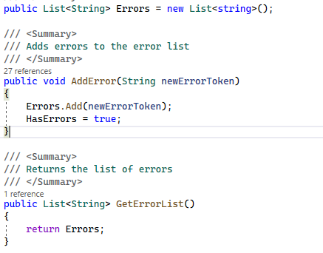
So a list has been created to store errors and the function AddError() adds errors to the list and the function GetErrorList() return all the errors in the compiler.
All the places that say //error, error reporting is done including the classes like TypeChecker.cs, TargetCodeWriter.cs, Tokenizer.cs, TargetCode.cs and all the other classes. It is basically called using the function AddError() initialised in the ErrorReporting.cs class. Here is an example of error reporting from the TargetCode.cs class.
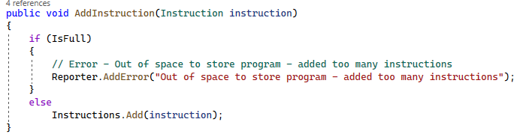

TokenType.cs
At line 18: Loop and Repeat were added as reserved words to match with the mini triangle grammar.
At line 21: QuestionMark (?) and EqualTo (=>) punctuation words were added to match with the mini triangle grammar.
At line 48,49,50,51: The extra reserved words and punctuation were added to the dictionary for the grammar.
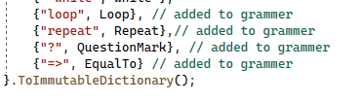

Compiler.cs
The function WriteFinalMessage() was completed, the errors were stored in the list and then the method GetErrorList() was called to get the errors and finally if there are any errors the terminal will the display the errors using WriteLine method otherwise the terminal will show program build successful. The terminal will also show the number of errors encountered during the runtime.
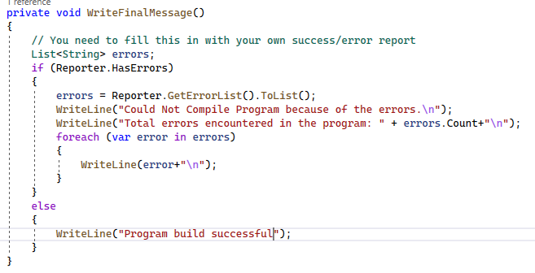

Parser.cs
New cases were added to match the grammar of the compiler.
At line 132,133,134,135: Case Loop and Case QuestionMark was added to complete the grammar.
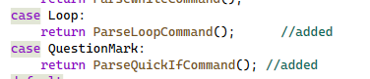
2 new commands were added respective to the cases:
ParseLoopCommand(): This command first accepts the Loop keyword and then parses a single command and then accepts the While keyword and then parses the expression and at the end again parses a single command.
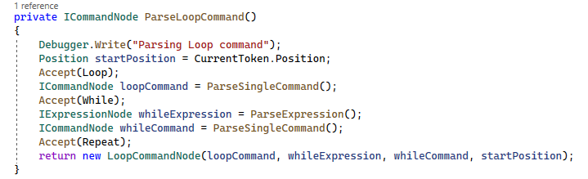
ParseQuickIfCommand(): This command first accepts a Question mark(?) followed by parsing an expression and then accepts the EqualTo keyword followed by parsing a single Command
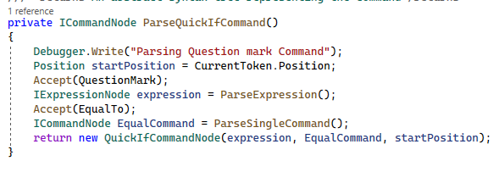

LoopCommandNode.cs
A new command node was added to the command nodes folder which implements the ICommandNode interface. This node contains 2 commands: LoopCommand and WhileCommand and contains 1 expression: WhileExpression. Together they help parcer.cs to compile the program.
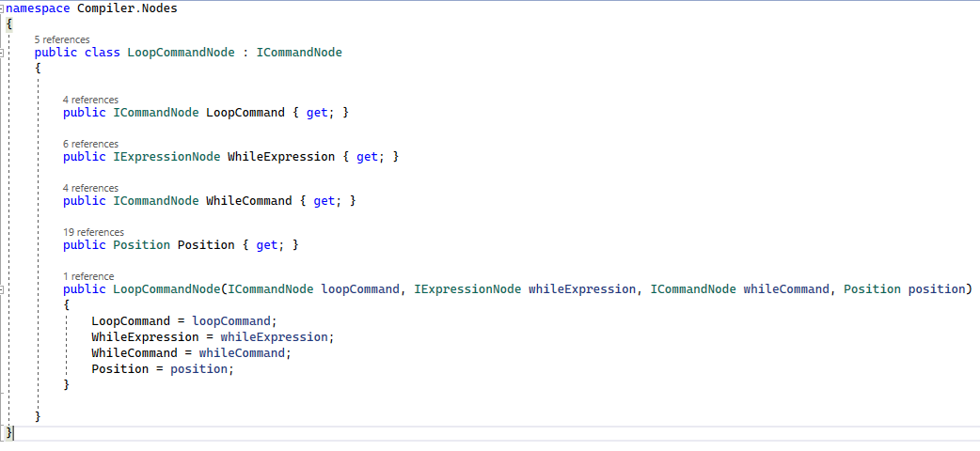

QuickIfCommandNode.cs
Another command node was added to the command nodes folder which also implements ICommandNode interface. This node contains 1 expression: Expression and 1 command: EqualComand. Together they help parcer.cs to compile the program.
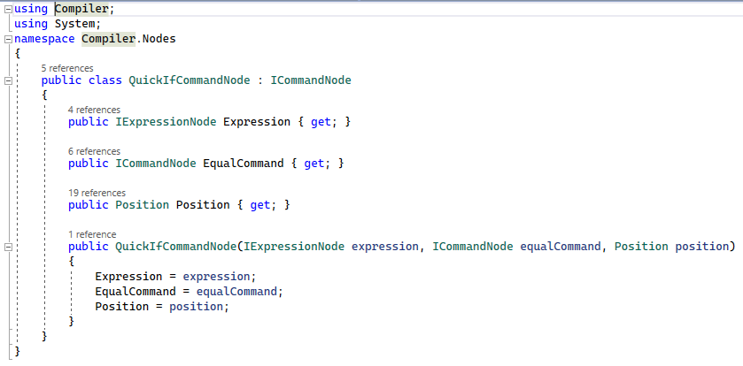

CodeGenerator.cs
2 New methods were added on line 101 and 126 namely GenerateCodeForLoopCommand() and GenerateCodeForQuickIFCommand().
GenerateCodeForLoopCommand(): This command first generates code for loopCommand and calculates the new jump address for that command and adds instruction to jump to the patchInstruction line of code with a False value. Then it generates code for while expression and does the same steps above until the values turns out to be true and finally generates command for whileCommand. The LoopCommand runs continuously until it has reached a true value.
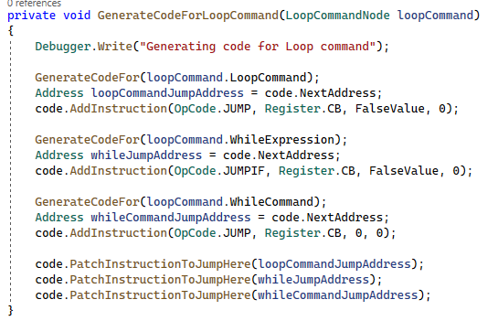
GenerateCodeForQuickIFCommand(): This method first generates code for the expression and calculates its new jump address and adds instruction to jump to the line patchInstruction followed by generating code for EqualCommand following the same process mentioned above.
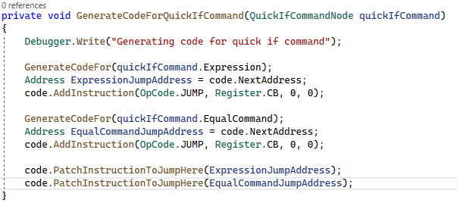

DeclarationIdentifier.cs
2 new methods were added in the class on line 74 and 85 namely PerformIdentificationOnLoopCommand() and PerformIdentificationOnQuestionMarkCommand().
PerformIdentificationOnLoopCommand(): This method performs identification on the variables declared in the LoopCommandNode.cs class.
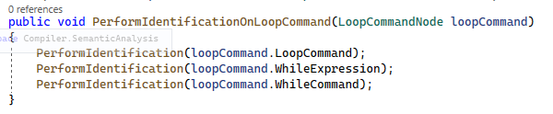
PerformIdentificationOnQuestionMarkCommand(): This method performs identification on the variables declared in the QuickIfCommandNode.cs class.
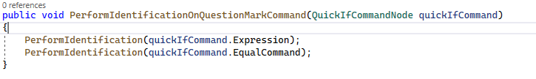

StandaradEnvironment.cs
As the identifiers must be case sensitive, I have changed the names of the types and converted it to lower case so that identifiers can be easily distinguished.
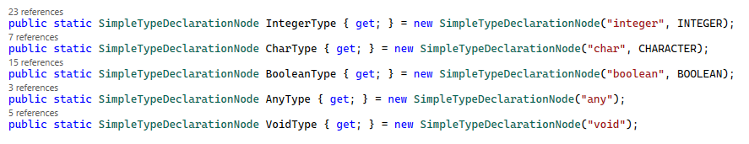
The following changes were made: -
Integer – integer
Char – char
Boolean – boolean
Any – any
Void – void

TypeChecker.cs
2 new methods were added on the line 76 and 92 namely PerformTypeCheckingOnLoopCommand() and PerformTypeCheckingOnQuickIfCommand()
PerformTypeCheckingOnLoopCommand(): This method checks the loop command and returns a Boolean value similar to all other type checkers. It checks if the LoopCommand, WhileExpression and WhileCommand are implemented correctly.
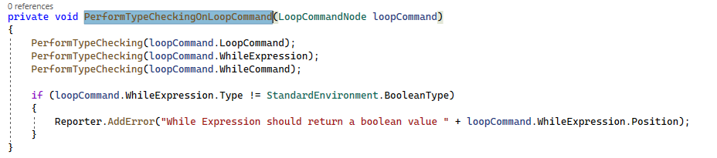
PerformTypeCheckingOnQuickIfCommand(): This method checks the Quick if command and returns a Boolean value similar to all other type checkers. It checks if the Expression and the EqualCommand are implemented correctly.
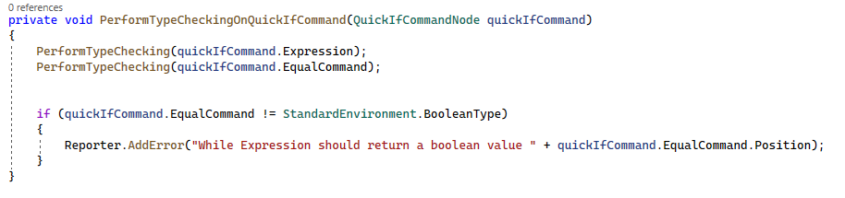

Also, all the error reporting has been done where needed such that they all return a Boolean value using Reporter.AddError().

Program Example
Lastly, when everything was added to the unfinished compiler code, I ran a test to see whether the compiler is properly working or not. Here I took example_chars.tri and tried to run on the compiler and it turn out the compiler works properly and shows the user the errors in their code.
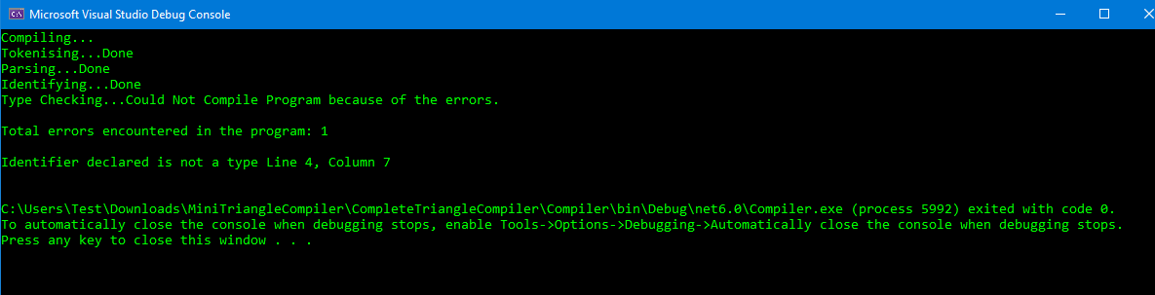
It tells the error is at line 4 and it says the declared identifier is a wrong type.

